**Beschreibung: nova_Institut_fOuI_4c_enPress release**

*nova-Institut GmbH (*[*www.nova-institute.eu*](http://www.nova-institute.eu)*)*

*Hürth, 10 November**2015*

**Bio-based polymers:** **Worldwide production capacity will triple from 5.7 million tonnes in 2014 to nearly 17 million tonnes in 2020.** **The data show a 10% growth rate from 2012 to 2013 and even 11% from 2013 to 2014. However, growth rate is expected to decrease in 2015. Consequence of the low oil price?**

**The new third edition of the market study is available by now. It includes consistent data from the year 2012 to the latest data of 2014 and the recently published data from** **European Bioplastics, the association representing the interests of Europe’s bioplastics industry. Bio-based drop-in PET and the new polymer PHA show the fastest rates of market growth. Europe looses considerable shares in total production to Asia. The bio-based polymer turnover was about** **€11 billion worldwide in 2014 compared to €10 billion in 2013. The third edition of the well-known** **500 page-market study and trend reports on “Bio-based Building Blocks and Polymers in the World – Capacities, Production and Applications: Status Quo and Trends Towards 2020”** **was published today****.** <http://bio-based.eu/markets>

Two years after the first market study was released, Germany’s nova-Institute publishes the third edition of the most comprehensive market study of bio-based polymers ever made in November 2015. This update expands the market study’s range, including bio-based building blocks as precursor of bio-based polymers. The nova-Institute carried out this study in collaboration with renowned international experts from the field of bio-based building blocks and polymers. The study investigates every kind of bio-based polymer and, for the second time, several major building blocks produced around the world.

In 2015, for the second time, the association “European Bioplastics” used nova-Institute’s market study as its main data source for their recently published market data. For the European Bioplastics’s selection of bio-based polymers, which differs from nova-Institute’s selection, bio-based polymers production capacities are projected to grow by more than 400% by 2019[[1]](#footnote-1).

The following table gives an overview on the covered bio-based polymers and the producing companies with their locations and production capacities from 2012 to 2014 – with corresponding yearly growth rates. In 2013, most of the polymers’ production capacities increased and contributed to the observed 10% compound annual growth rate (CAGR) from 2012 to 2013. Polyamides (PA), polyethylene terephthalate (PET) and polytrimethylene terephthalate (PTT) showed, with CAGR around 30%, the highest CAGR. In 2014, only few polymers contributed to the 11% CAGR from 2013 to 2014. Only epoxies and poly(butylene adipate-co-terephthalate) (PBAT) enjoy a strong market growth. Epichlorohydrin, whose production capacity increased, is precursor of epoxies and is produced from bio-based glycerin, a by-product from the biodiesel production. However, the overall growth rate is expected to decrease in 2015. This can certainly be explained by the low oil price and the low political support for bio-based polymers.

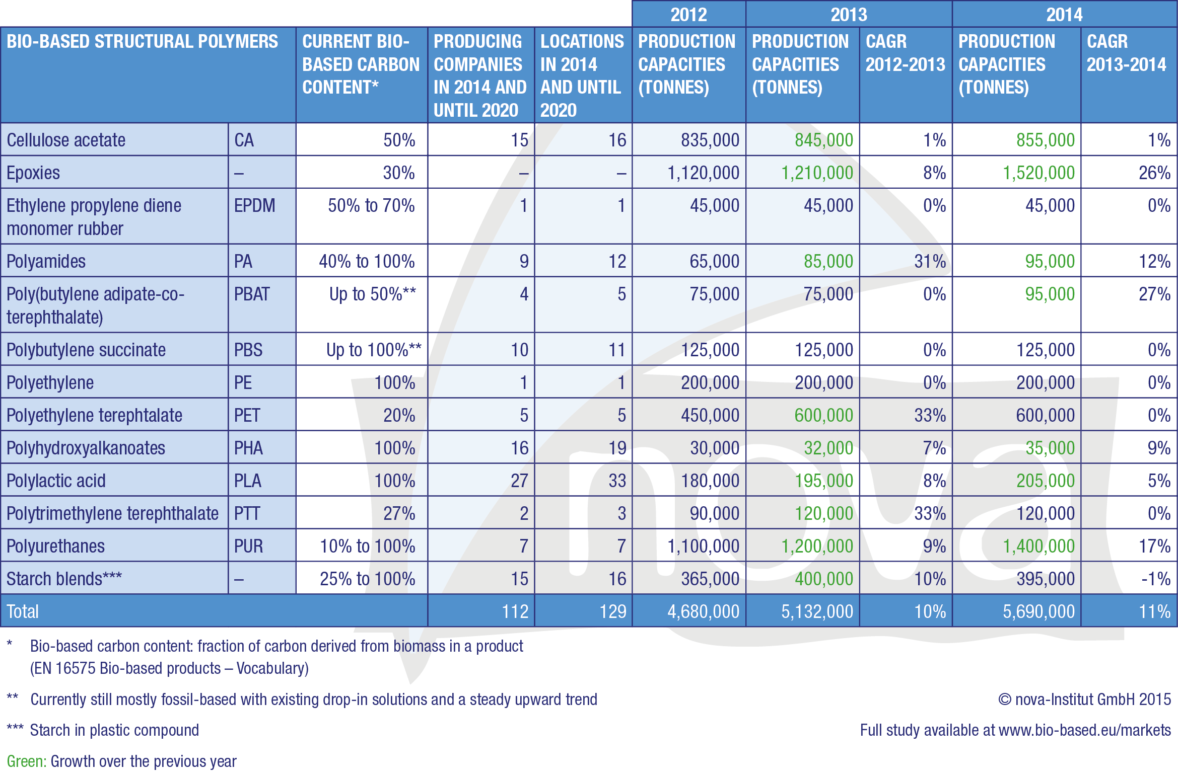

The production capacity for bio-based polymers boasts very impressive development and annual growth rates, with a compound annual growth rate (CAGR) of about 10% in comparison to petrochemical polymers, which have a CAGR between 3-4%. The 5.7 million tonnes bio-based polymer production capacity represent approximately a 2% share of overall structural polymer production at 256 million tonnes in 2013 and a bio-based polymer turnover of about €11 billion in 2014 (5.7 Mio. t (production capacity) x €2.50/kg (estimated average bio-based polymer price) x 0,8 (capacity utilization rate)). With an expected total polymer production of about 400 million tonnes in 2020, the bio-based share should increase from 2% in 2013 to more than 4% in 2020, meaning that bio-based production capacity will grow faster than overall production.

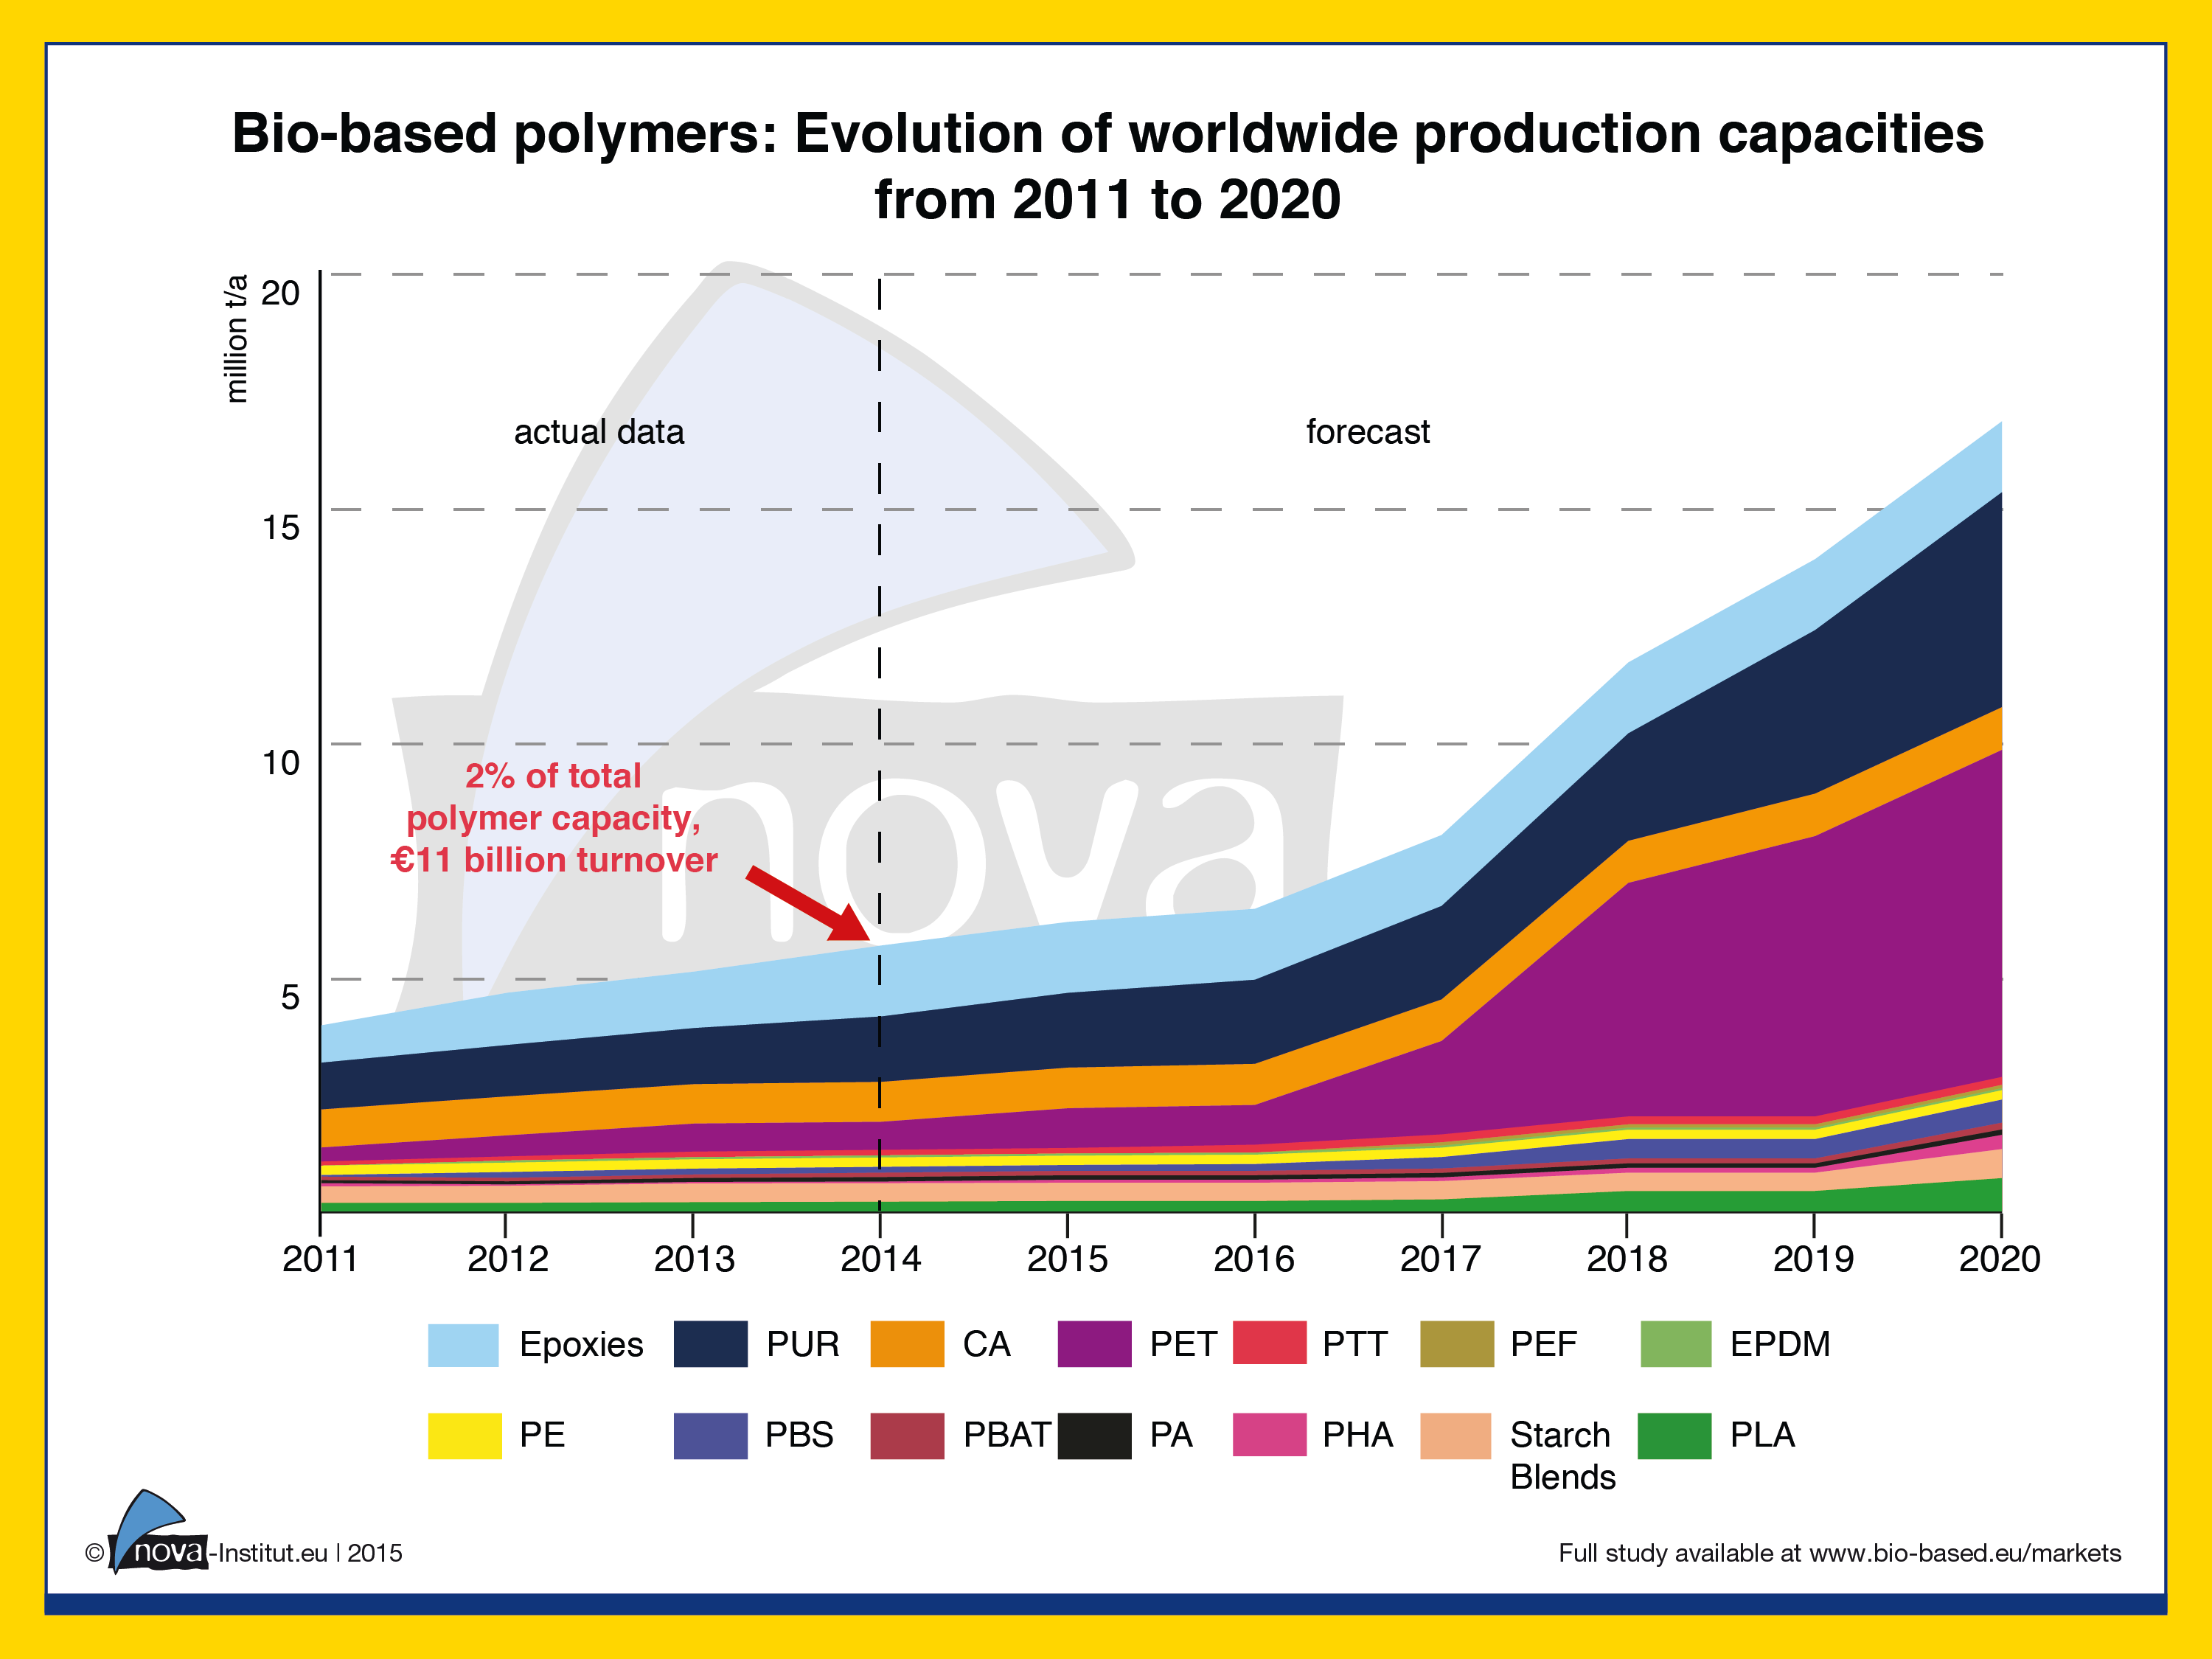

The most dynamic development is foreseen for drop-in bio-based polymers, but this is closely followed by new bio-based polymers. Drop-in bio-based polymers are chemically identical to their petrochemical counterparts but at least partially derived from biomass. This group is spearheaded by partly bio-based polyethylene terephthalate (PET), largely due to the Plant PET Technology Collaborative (PTC) initiative launched by The Coca-Cola Company. The second most dynamic development is foreseen for polyhydroxyalkanoates (PHA), which, contrary to bio-based PET, are new polymers, but still have similar growth rates to those of bio-based PET. Polybutylene succinate (PBS) and polylactic acid (PLA) are showing impressive growth as well: their production capacities are expected to almost quadruple between 2014 and 2020.

Most investment in new bio-based polymer capacities will take place in Asia because of better access to feedstock and favorable political framework. Europe’s share is projected to decrease from 15.4% to 4.9%, and North America’s share is set to fall from 14% to 4.1%, whereas Asia’s is predicted to increase from 58.1% to 80.6%. South America is likely to remain constant with a share between 10% and 12%. In other words, world market shares are expected to shift dramatically. Asia is predicted to experience most of the developments in the field of bio-based building block and polymer production, while Europe and North America are slated to lose more than two thirds of their shares.

This **500 page-report** presents the findings of nova-Institute’s market study, which is made up of three parts: “market data”, “trend reports” and “company profiles” and contains over 200 tables and figures.

The **“market data”** section presents market data about total production capacities and the main application fields for selected bio-based polymers worldwide (status quo in 2011, 2013 and 2014, trends and investments towards 2020). This part not only covers bio-based polymers, but also investigates the current bio-based building block platforms.

The **“trend reports”** section contains a total of eleven independent articles by leading experts in the field of bio-based polymers These trend reports cover in detail every recent issue in the worldwide bio-based building block and polymer market.

The final “**company profiles**” section includes about 100 company profiles with specific data including locations, bio-based building blocks and polymers, feedstocks and production capacities (actual data for 2011, 2013 and 2014 and forecasts for 2020). The profiles also encompass basic information on the companies (joint ventures, partnerships, technology and bio-based products). A company index by bio-based building blocks and polymers, with list of acronyms, follows.

**The full report can be ordered for €3,000 plus VAT and the short version of the report can be downloaded for free at** [**www.bio-based.eu/markets**](http://www.bio-based.eu/markets)**.**

**Please download the figures included in the press release at the following link. Use of the material is free of charge for press purposes.**

**<http://bio-based.eu/market_study/media/15-11-10-Graphics-biopolymers-nova.zip>**

**The zip-file includes:**

* 15-11-10\_Bio-based\_polymers-companies\_production\_capacities\_CAGR\_2012-2014.jpg (source: nova-Institute)
* 15-11-10\_Bio-based\_polymers-worldwide\_production\_capacities\_2011-2020.jpg (source: nova-Institute)

**Contact**:

**Dipl.-Ing.  Florence Aeschelmann**

Phone: +49 (0) 22 33-48 14-48

[florence.aeschelmann@nova-institut.de](mailto:florence.aeschelmann@nova-institut.de)

**Responsible under press legislation (V.i.S.d.P.):**  
Dipl.-Phys. Michael Carus (Managing Director)

nova-Institut GmbH, Chemiepark Knapsack, Industriestraße 300, DE-50354 Hürth (Germany)

Internet: [www.nova-institute.eu](http://www.nova-institute.eu) – all services and studies at [www.bio-based.eu](http://www.bio-based.eu/en/index.html)

Email: [contact@nova-institut.de](mailto:contact@nova-institut.de)

Phone: +49 (0) 22 33-48 14-40

nova-Institute is a private and independent institute, founded in 1994; nova offers research and consultancy with a focus on bio-based and CO2-based economy in the fields of feedstock, techno-economic evaluation, markets, LCA, dissemination, B2B communication and policy. Today, nova-Institute has 25 employees and an annual turnover of more than 2 million €.

1. Market data graphics from European Bioplastics are available for download in English and German:

   <http://en.european-bioplastics.org/press/press-pictures/labelling-logos-charts/> [↑](#footnote-ref-1)